

**FoodShop Application**

**Software Design Specification**

**june 25th, 2021**

* Nguyễn Minh Tiến
* Phan Ngọc Luân
* Đào Văn Chung
* Nguyễn Hữu Thắng
* Cao Minh Hiếu
* Nguyễn Huỳnh Quốc Trung

Table of Contents

Table of Contents 2

I. Introduction 5

3. Major constraints 5

II. Data design 5

4. Internal software data structure 5

III. Architectural design 5

5. Program Structure 5

6. Architecture diagram 6

7. Schedule 6

7.1. Scheduling diagram 7

8. Definition of milestones 8

8.1. Requirements Doc 8

o receive relevant documents , and read and understand it in the time allotted 8

9. Component-level design 8

9.1 Description for Onboard Screen 8

9.2. Processing narrative for Onboard Screen 8

20

21

10. Test Case product- detail 22

# Introduction

This document outlines the requirements for the production and design of "foodie" software for the ios operating system. The product will have 2 main functions: "view" and "order". The user interface will be easy to use and allow users to switch between pages

1. Goals and objectives

* The goal of this project is to create an application that competes with existing food selling applications.

1. **Software context**

* The big picture of this project will be to feed anyone who has access to an ios device

## Major constraints

* First time should write in swift language, so it's still difficult

# Data design

## Internal software data structure

The data of each function will mainly be kept separate. Each function will use the most appropriate method to store their data. All data will be stored in function specific variables

# Architectural design

## Program Structure

Customer after accessing the application. Will be able to view the dishes and order them in the fastest way

### Architecture diagram

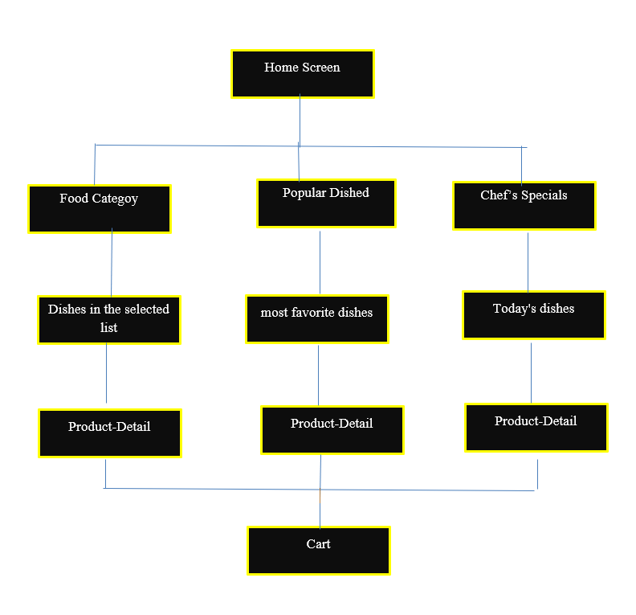

# Schedule

The development of this program will go through three main cycles. The first cycle is the Documentation Phase, where the Software Design and Requirements Documents are built. These documents will provide the team with a layout for each module and a diagram of how everything works together. The second cycle will be the actual coding of each module (and subroutines). This involves members completing assigned subscreen interfaces. This includes individual submenus, modular design, and modular testing. At the end of this cycle, they expect to have standalone displays ready for system integration. The third and final cycle requires total system integration and testing. During this phase, all screens and function menus are integrated and tested. If time permits, interface improvements and documentation updates can be made in advance during this time.

## 7.1. Scheduling diagram

|  |  |  |  |  |
| --- | --- | --- | --- | --- |
| ID | Task Name | Start | Finish | Duration |
| 1 | Requirements Doc | 15/4/2021 | 30/4/2021 | 10day |
| 2 | Write SRS | 20/4/2021 | 25/4/2021 | 3 day |
| 3 | Software design | 17/04/2021 | 30/04/2021 | 5 day |
| 4 | Design Onboard | 3/5/2021 | 4/5/2021 | 5 hour |
| 5 | Design Home Screen | 3/5/2021 | 5/5/2021 | 1 day |
| 6 | Design Food Category Screen | 4/5/2021 | 7/5/2021 | 1 day |
| 7 | Design Product detail Screen | 4/5/2021 | 7/5/2021 | 2 day |
| 8 | Design Popular Dished Screen | 4/5/2021 | 7/5/2021 | 1 day |
| 9 | Design Chef’s Specials Screen | 4/5/2021 | 7/5/2021 | 1day |
| 10 | Design Cart Screen | 4/5/2021 | 10/5/2021 | 2 day |
| 11 | Check out the design screens | 11/5/2021 | 20/5/2021 | 5 day |
| 12 | connect to firebase | 20/5/2021 | 15/6/2021 | 15 day |
| 13 | Input datas | 15/6/2021 | 16/6/2021 | 1 hour |
| 14 | write SDS | 15/6/2021 | 20/6/2021 | 5 day |
| 15 | Demo application and fix error | 20/6/2021 | 26/6/2021 | 6 day |

## Definition of milestones

### 8.1. Requirements Doc

### receive relevant documents , and read and understand it in the time allotted

**8.2.** **Software design**

* Plan time, analyze and design the interface for the application according to the requirements of srs

# Component-level design

* Our system is based on a main menu through which individual pages can be accessed.

## 9.1 Description for Onboard Screen

* Display the store's maxim, increasing the customer's eye-catching when entering the application

### 9.2. Processing narrative for Onboard Screen

* After entering the application, the customer will see the application introduction screen.
* The user can press “next” to go to the next screen, until the start button “Get Started”

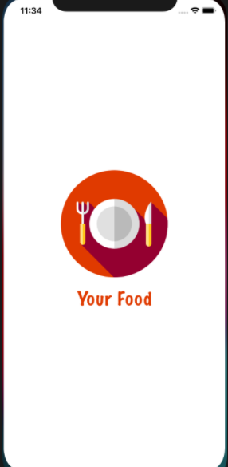

*Image1: First Screen*

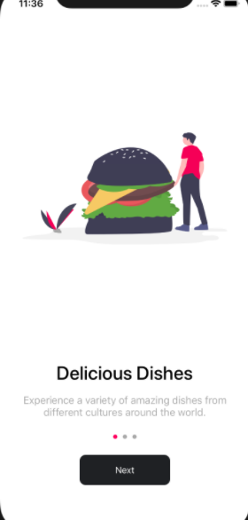

*Image 2: onboard Screen*

. 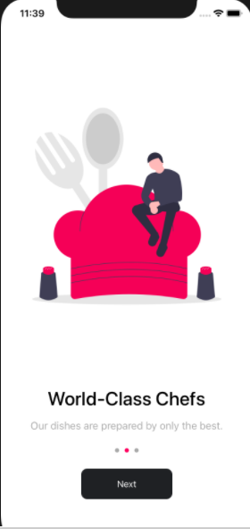

*Image 3: onboard Screen*

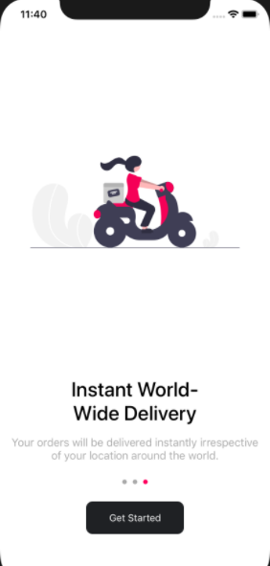

*Image4: onboard screen 3*

* 1. Description for Home Screen
* MyMobile Home Screen has:
* Name shop: The name of the app
* FoodCategory: Display the food items in the shop. When Tap on the Category box on the screen it show the foods of that category
* Popular Dished: Show the dishes with the most views and orders. When tap on the dish in the popular dishes box, Show that product information
* Chef’s Specials: Display the special dishes that the shop has for sale today. When Tap on the dish in the Chef’s Specials box, show that product information
* Cart: Contains customer orders. When tap cart lable on the home screen, displays a list of orders that have been placed

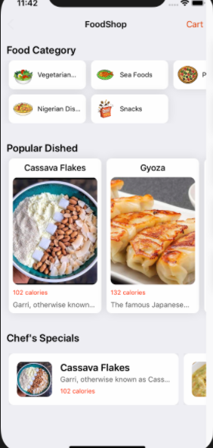

*Image5 : home screen*

* 1. Description for Food Category
* Food Category has:
* Name of the type foods: Display the food items in the shop. When tap on the Category box on the screen it show the foods of that category.
* List of dishes: Display the list of dishes of the selected dish type. When selecting a dish, the details of that dish will be displayed.

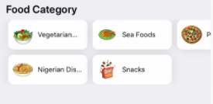

*Image 6 : Food Category*

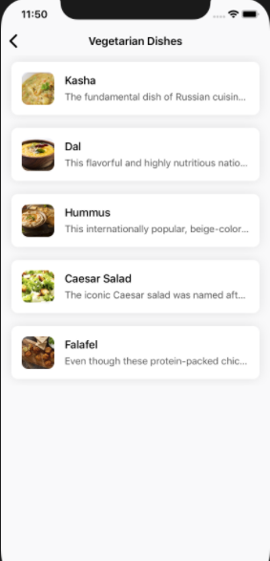

*Image 7 : screen vegetarian dishes*

* 1. Description for product -detail 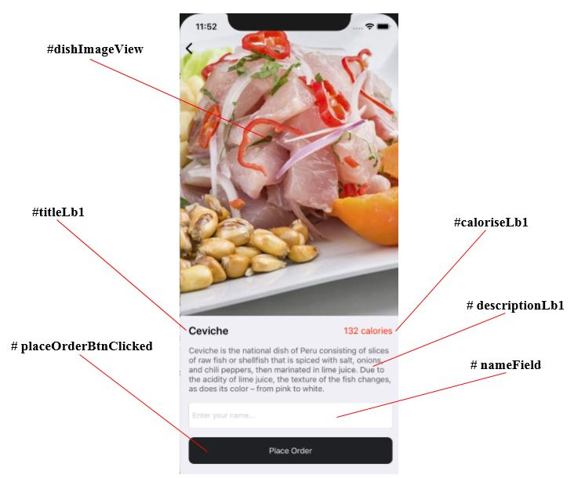

|  |  |
| --- | --- |
|  | **Description:** Product name(titleLb1) + Product prices(caloriseLb1) + Product description(descriptionLb1) |
|  | **Confirmation function:** Customer name (nameField) + Confirm button(placeOrderBtnClicked) |

**#Description:**

Product name: Help you know about the name of the dish you clicked on.

Product prices: Help you know about the price of the food that we are selling. Product description: Help you better understand the food you are watching in a close looking and easy to understand way.

**#Tutorial to order:**

You just need to enter your name in the **Customer namer** **⭢** click on **Place Order** **⭢** Your dish will be added **Order List.**

* 1. Description for Popular Dished Screen

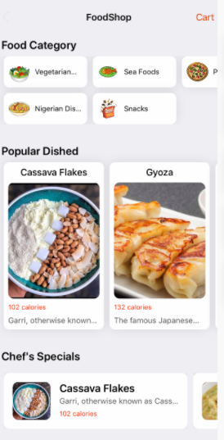

+ Show full information : Popular dish category , Price , Dish Name , Dish Details Image , Use horizontal scroll bar to view more dishes .II. Phân tích giao diện

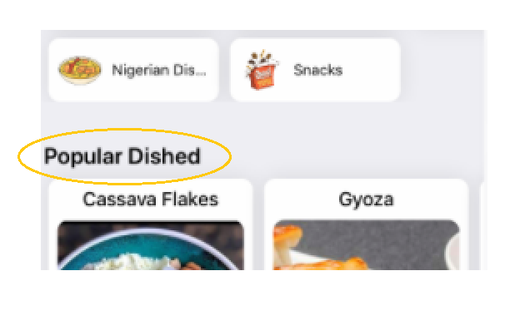

+ **Popular Dished** is a type of dish in 2 categories Special and Popular of the software, Popular Dished is a popular dish and with a stable price and a number of regular buyers, it should be listed on the list of popular dishes. Out .

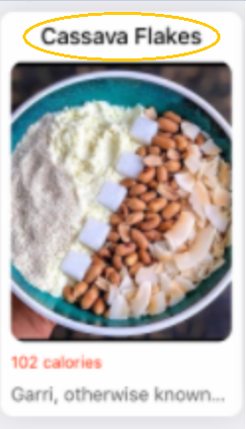

+ ***Cassava Flakes*** is the name of the dish .

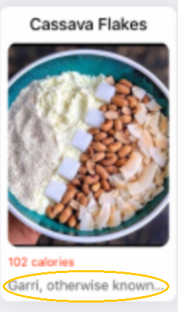

+ The above is the product details you can click on this category to see full information as well as the price of this dish.

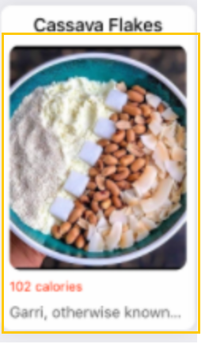

+ This section is Collectionviewcellclick for customers to select to see more details about the product as well as place an order..

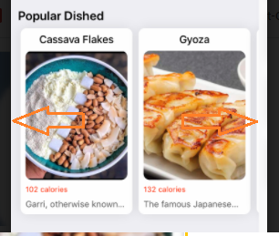

+ You can use the mouse pointer in the arrow direction to activate the scroll bar and see more dishes nhiều .

* 1. Description for Chef’s Specials Screen
* MyMobile Chef’s SpecialsScreen has :
* List of items that will be sold today . When Tap on any product on Chef’s Specialsbox . Result show that product information

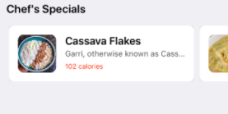

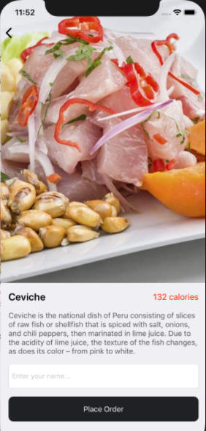

* 1. Description for Cart Screen



·       **Functional Requirements**

|  |  |  |  |
| --- | --- | --- | --- |
| Item | Description | Action | Response |
| "Enter name" TextInput | Used to enter the username, if not entered, the message "Please enter information" | Enter a name | The name will be displayed in TextInput |
| "Place Order" Button | Used to transfer information "user name", "dish name" and display it on the list order page | Tap to switch pages | Switch to the Order screen |
|  |  |  |  |

1. **Order Interface:**

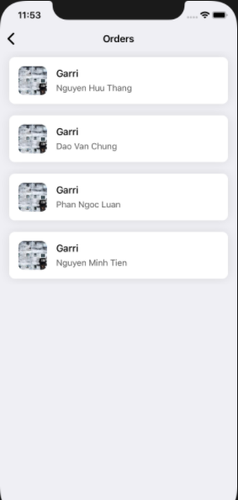

·       **Functional Requirements**

|  |  |  |  |
| --- | --- | --- | --- |
| Item | Description | Action | Response |
| "Username" Label | Used for display | display | Show the user name that just ordered the item |
| "Name " Label | Used for display | display | Show The name of the ordered item |
| “Food photos”ImageView | Used for display | display | Show a picture of the item you just ordered |
| "Dish Information" Button | Used to switch to the dish details screen | Tap | Go to the dish details screen |

1. **Test Case product- detail**

|  |  |  |  |  |
| --- | --- | --- | --- | --- |
| **Title** | **Area** | **Steps** | **Expected Results** | **Results** |
| **dishImageView** | Dish Detail View Controller | N/A | Hiển thị hình ảnh | **PASS** |
| **titleLb1** | Dish Detail View Controller | N/A | Display title / product name | **PASS** |
| **caloriseLb1** | Dish Detail View Controller | N/A | Display product prices | **PASS** |
| **descriptionLb1** | Dish Detail View Controller | N/A | Display product description | **PASS** |
| **nameField** | Dish Detail View Controller | Click on **nameField**  **⭢** Enter customer name | Customer name | **PASS** |
| **placeOrderBtnClicked (Place Order)** | Dish Detail View Controller | Enter customer name + click on **Place Order** | Navigate to **Order List**. | **PASS** |

* 1. **Result** :

Functions made:

* Display images.
* Display product name.
* Display product prices.
* Display product description.

Function not available:

* .

Additional functions if more time is available:

* Can rate product.
* Can see more product images.
* Can add product to favorites.